Pokhara University

Level: Bachelor | Semester: Fall | Year : 2010
Programme: BE |  | Full Marks: 100
Course: Electrical Engineering Material |  | Pass Marks: 45
 |  | Time : 3hrs.

Candidates are required to give their answers in their own words as far as practicable.
The figures in the margin indicate full marks.

Attempt all the questions.

 | - Derive time independent SchrÖdinger's equation. Starting with classical wave equations 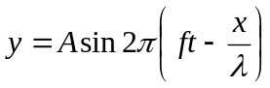, where the notations have their usual meanings.  - If an electron is placed inside a potential well of width (L), find the energy and wave functions of electron. Also sketch them for n=1,2and 3.  (theory of metals) | 8  7
 | - What do you mean by effective mass of an electron? Explain the significance of negative and infinite effective mass.  - If electrical conductivity of potassium is 1.39×10⁵ Sm/cm, calculate the drift mobility of electron at room temperature. Molar mass and density of potassium are 39.95 and 0.91 gm/cc. | 8  7
 | - What is ionic conduction? Derive the relation for ionic conductivity as 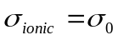exp [-Q/KT].  - A parallel plate capacitor has an area of 10 cm² and a separation of 0.1mm.The space between the plates is filled with polyethylene. An alternative voltage with amplitude of 2 volts is applied at a frequency of 1 MHz. At this frequency the real part of the relative permittivity is 2.25 and the loss tangent is 4×10⁻⁴.Calculate the energy dissipated per second. | 8  7
 | - Describe in brief about the types of polarization in dielectric materials.  - Explain the domain structure and domain walls of ferromagnetic materials. | 8  7
 | - Why ferrites are used for high frequency applications? Explain.  - n-type semiconductor doped with 10¹⁶cm⁻³ phosphorous atoms has been doped with boron atoms. Calculate the electron and hole concentrations in the semiconductors. | 7  8
 | - Show that the diode equation for a P-N junction is 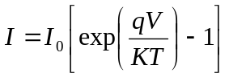where I₀ is the reverse saturation current and V is the applied voltage.  - Define the term wafer? Explain ion implantation process with neat and clean diagram. | 8  7
 | Write short notes on (Any Two)  - Epitaxial growth  - Compensation doping  - Hard and soft magnetic materials | 2×5

